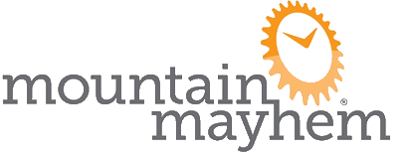
16 & 17 YEAR OLD PARENTAL CONSENT FORM
This form must be completed, printed and signed by a parent or guardian and presented at registration in order that they can ride.
Participant Details  Name  Surname  DOB (dd/mm/yy)  Sex  MaleFemale  Email Address  Address | Emergency Contacts  Name(s)  Contact Telephone(s)  Relationship to Participant
Medical Information
Please make a note below and provide any information required about medical conditions you feel we need to know about, eg. asthma or any allergies. If you have any concerns about your child participating in any form of physical activity, then please consult your GP before giving permission for your child to take part in Mountain Mayhem.
Consent
Sign below to confirm you consent to the above-named participant entering Mountain Mayhem.
Name
Date (dd/mm/yy)

Signed:

